**IT LAB CYCLE-1 (HTML)**

**Question 1**

**Filename** **- q1.html**

<!DOCTYPE html>

<html>

    <head>

        <meta charset = "utf-8">

        <title>Trivandrum</title>

        <style>

            img{

                    display: block;

                    margin-right: auto;

                    margin-left: auto;

                    width: 50%;

                }

        </style>

    </head>

    <body>

        <h1 style="text-align:center">Trivandrum</h1>

        <p><b>Thiruvananthapuram (or Trivandrum) is the capital of the southern Indian state of Kerala.</b></p>

        <p><i>It is the most populous city in Kerala with a population of 957,730 as of 2011</i></p>

        <p><ins>Referred to by Mahatma Gandhi as the "Evergreen city of India",the city is characterised by its undulating terrain of low coastal hills.</ins></p>

        <hr>

        <a href = "#tourist_places">Tourist Places in TVM</a>

        <hr>

        <h2 style="text-align:center">Map of Trivandrum District</h2>

        <img src="http://www.justkerala.in/wp-content/uploads/2012/11/thiruvananthapuram.gif" alt="Trivandrum District" width="375" height="550">

        <h2 id = "tourist_places"> Important Tourist Places in Trivandrum</h2>

        <ul>

            <li>Sree Padmanabhaswamy Temple</li>

            <li>Napier Museum</li>

            <li>Thiruvananthapuram Zoo</li>

            <li>Shanghumughm Beach</li>

            <li>Vizhinjam Lighthouse</li>

            <li>Kovalam Beach</li>

            <li>Beemapally Mosque</li>

            <li>Kanakakunnu Palace</li>

        </ul>

    </body>

</html>

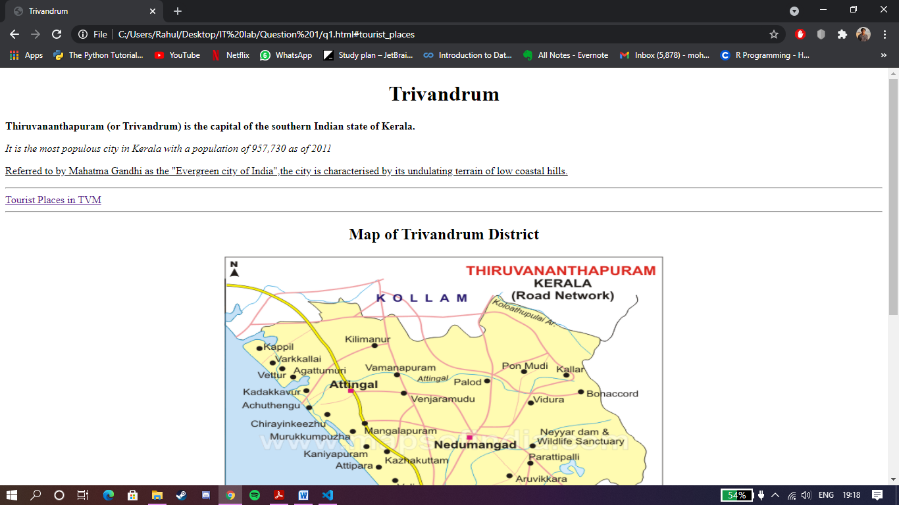

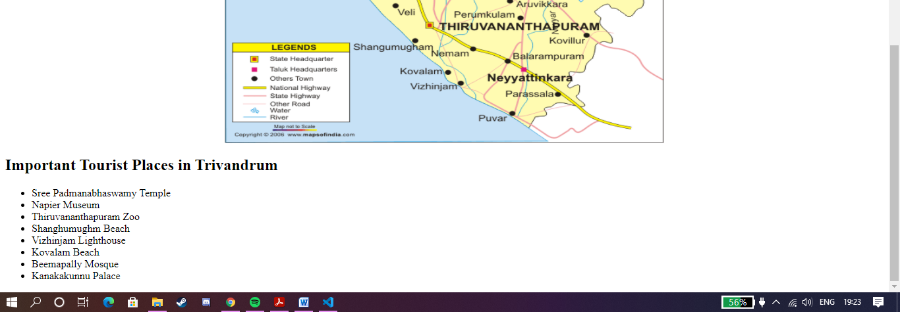

**Question 2**

**File name – q2.html**

<!DOCTYPE html>

<html>

    <head>

        <meta charset="utf-8">

        <title>List</title>

    </head>

    <body>

        <h2>Components of computer</h2>

        <ul>

            <li>Software

                <ol>

                    <li>system software

                        <ol type="i">

                            <li>operating system

                                <ol type="a">

                                    <li>MS Windows</li>

                                    <li>Linux</li>

                                    <li>Android</li>

                                </ol>

                            </li>

                            <li>language processor</li>

                            <li>utility software</li>

                        </ol>

                    </li>

                    <li>Application Software

                        <ol>

                            <li>word processors</li>

                            <li>graphic software</li>

                            <li>database software</li>

                        </ol>

                    </li>

                </ol>

            </li>

            <li style="list-style-type:square;">hardware

                <ol start="5">

                    <li>monitor</li>

                    <li>mouse</li>

                    <li>Keyboard</li>

                </ol>

            </li>

        </ul>

    </body>

</html>

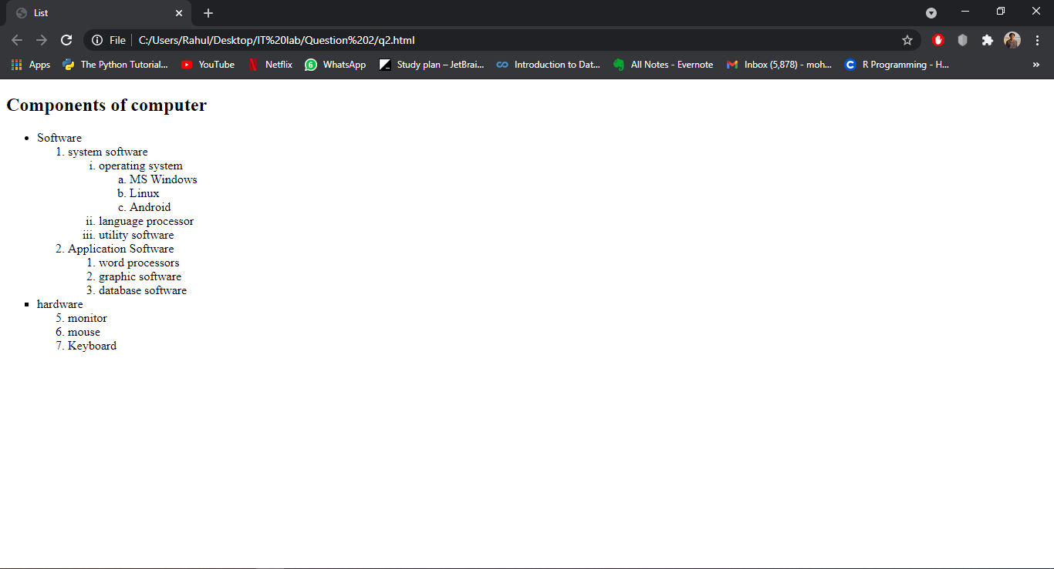

**Question 3.1**

**File name – q3(1).html**

<!DOCTYPE html>

<html>

    <head>

        <meta charset="utf-8">

        <title>Table 1</title>

        <style>

            table, th, td {

                border: medium solid black;

                border-collapse: collapse;

            }

            td{

                text-align: center;

            }

        </style>

    </head>

    <body>

        <table width ="400">

            <thead>

                <tr>

                    <th rowspan="3">Force(N)</th>

                    <th colspan="2">Extension(cm)</th>

                    <th rowspan="3">Average extension(cm)</th>

                </tr>

                <tr>

                    <th>Test 1</th>

                    <th>Test 2</th>

                </tr>

            </thead>

            <tbody>

                <tr>

                    <td>0.0</td>

                    <td>0.0</td>

                    <td>0.0</td>

                    <td>0.0</td>

                </tr>

                <tr>

                    <td>1.0</td>

                    <td>5.5</td>

                    <td>5.5</td>

                    <td>5.5</td>

                </tr>

                <tr>

                    <td>2.0</td>

                    <td>11.1</td>

                    <td>11.0</td>

                    <td>11.1</td>

                </tr>

                <tr>

                    <td>3.0</td>

                    <td>16.7</td>

                    <td>16.5</td>

                    <td>16.6</td>

                </tr>

                <tr>

                    <td>4.0</td>

                    <td>22.2</td>

                    <td>22.1</td>

                    <td>22.2</td>

                </tr>

                <tr>

                    <td>5.0</td>

                    <td>27.5</td>

                    <td>27.5</td>

                    <td>27.5</td>

                </tr>

                <tr>

                    <td>6.0</td>

                    <td>33.2</td>

                    <td>33.1</td>

                    <td>33.2</td>

                </tr>

                <tr>

                    <td>7.0</td>

                    <td>38.7</td>

                    <td>38.5</td>

                    <td>38.6</td>

                </tr>

            </tbody>

            </tbody>

        </table>

    </body>

</html>

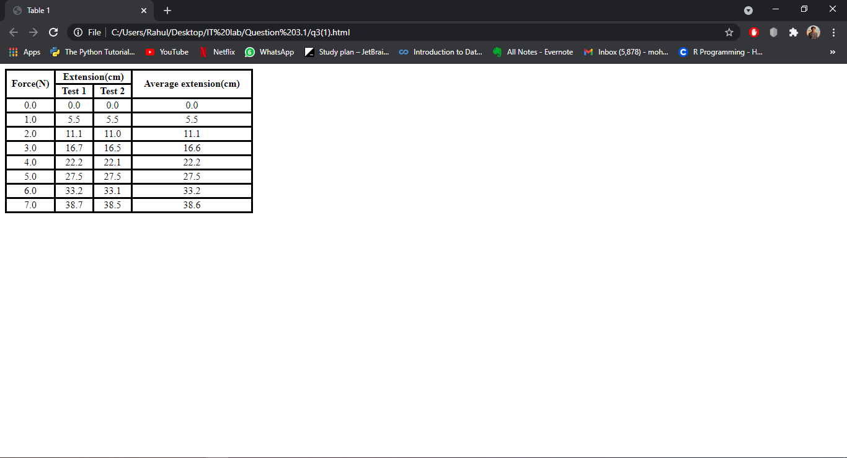

**Question 3.2**

**File name – q3(2).html**

<!DOCTYPE html>

<html>

    <head>

        <meta charset="utf-8">

        <title>Table 2</title>

        <style>

            table, th, td {

                border: thin solid black;

            }

            .center{

                margin-left: auto;

                margin-right: auto;

            }

        </style>

    </head>

    <body>

        <h1 style="text-align:center;">Table Example: Spanning Rows and Columns</h1>

        <table class="center" width = "600">

            <caption>A more complex sample table</caption>

            <thead>

                <tr>

                    <th rowspan="2"><img src="https://comps.canstockphoto.com/black-and-white-vector-silhouette-of-a-image_csp52841878.jpg" height="200" width="200"></img></th>

                    <th colspan="4">Camelid comparsion

                    <br> Approximate as of 06/2011</th>

                </tr>

                <tr>

                    <th># of humps</th>

                    <th>Indigenous region</th>

                    <th>Spits?</th>

                    <th>Produces wool?</th>

                </tr>

                <tr>

                    <th>Camels(bactrian)</th>

                    <td>2</td>

                    <td>Africa/Asia</td>

                    <td>Yes</td>

                    <td>Yes</td>

                </tr><tr>

                    <th>Llamas</th>

                    <td>1</td>

                    <td>Andes Mountains</td>

                    <td>Yes</td>

                    <td>Yes</td>

                </tr>

            </thead>

        </table>

    </body>

</html>

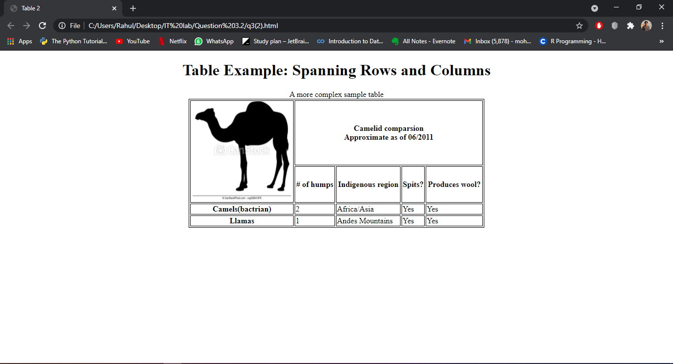

**Question 4**

**File name – q4.html**

<!DOCTYPE html>

<html>

    <head>

        <meta charset="utf-8">

        <title>Form</title>

        <style>

            #fname{

                margin-left: 200px;

            }

            #email{

                margin-left: 193px;

            }

            #edu{

                margin-left: 174px;

                width: 200px;

            }

            #resume{

                margin-left: 189px;

                border: thin solid black;

                width: 450px;

            }

            #address1{

                margin-left: 190px;

            }

            #address2{

                margin-left: 245px;

            }

            #country,#city{

                margin-left: 245px;

            }

            #country{

                width: 450px;

            }

            #phcode{

                margin-left: 145px;

            }

            #comp{

                margin-left: 140px;

            }

            #job{

                margin-left: 190px;

            }

            #duration{

                margin-left: 77px;

            }

            .csubs{

                font-size: 12px;

                color: grey;

                font-family: Verdana, sans-serif;

            }

            .csub1{

                margin-left: 243px;

            }

            .csub2{

                margin-left: 400px;

            }

            .csub3{

                margin-left: 320px;

            }

        </style>

    </head>

    <body>

        <h1 style="text-align: center;">Job Application</h1>

        <h2 style="color: darkred;">Personal Information</h2>

        <form method="post" action="http://www.deitel.com">

            <p>

                <label>

                    Name

                </label>

                <input name="firstname" type="text" size="15" id="fname" required>

                <input name="lastname" type="text" size="15" required>

                <br>

                <span class="csubs csub1">First name &nbsp&nbsp&nbsp&nbsp&nbsp&nbsp&nbsp&nbsp&nbsp&nbsp&nbsp&nbsp&nbsp&nbsp&nbsp&nbsp&nbsp&nbsp&nbspLast name</span>

            </p>

            <p>

                <label>E-mail

                    <input name="email" type="email" id="email" size="35" placeholder="user@example.com" required>

                </label>

            </p>

            <p>

                <label>Education

                    <select name="eduction" id="edu" required>

                        <option selected value="" disabled selected hidden>Please choose</option>

                        <option value="highschool">High school</option>

                        <option value="graduate">Graduate</option>

                        <option value="postgraduate">Post graduate</option>

                        <option value="doctorate">Doctorate</option>

                        <option value="other">Other</option>

                    </select>

                </label>

            </p>

            <p>

                <label>Resume

                    <input name="resumeupload" type="file" id="resume" required>

                </label>

            </p>

            <p>

                <label>

                    Address

                </label>

                <input name="address1" type="text" id="address1" size="60" required>

                <br>

                <span class="csubs csub2">Address 1</span>

                <br>

                <input name="address2" type="text" id="address2" size="60" required>

                <br>

                <span class="csubs csub2">Address 2</span>

                <br>

                <select name="country" id="country" required>

                    <option selected value="" disabled selected hidden>Select a Country</option>

                    <option value="Afghanistan">Afghanistan</option>

                    <option value="Åland Islands">Åland Islands</option>

                    <option value="Albania">Albania</option>

                    <option value="Algeria">Algeria</option>

                    <option value="American Samoa">American Samoa</option>

                    <option value="Andorra">Andorra</option>

                    <option value="Angola">Angola</option>

                    <option value="Anguilla">Anguilla</option>

                </select>

                <br>

                <span class="csubs csub2">Country</span>

                <br>

                <input type="text" name="city" size="25" id="city" required>

                <input type="text" name="state" size="5" id="state" required>

                <input type="text" name="zipcode" size="15" id="zipcode" required>

                <br>

                <span class="csubs csub3">City &nbsp&nbsp&nbsp&nbsp&nbsp&nbsp&nbsp&nbsp&nbsp&nbsp&nbsp&nbsp&nbsp&nbsp&nbsp&nbsp&nbsp&nbsp&nbsp&nbsp&nbsp&nbsp&nbsp&nbsp&nbsp&nbsp&nbsp&nbsp&nbsp&nbsp&nbsp State &nbsp&nbsp&nbsp&nbsp&nbsp&nbsp&nbsp&nbsp&nbsp&nbsp&nbsp&nbsp&nbsp&nbsp&nbsp&nbsp&nbsp&nbsp Zip code</span>

            </p>

            <p>

                <label>Phone Number

                    <input name="code" type="text" id="phcode" size="2" required>

                    <input name="phoneno" type="tel" size="45" required>

                </label>

            </p>

            <p>

                <label>What are your hobbies?<br>

                    <input name="hobbies" type="text" size="120" required>

                </label>

            </p>

            <h2 style="color: darkred;">Previous/Current Employee Details</h2>

            <p>

                <label>Company Name

                    <input name="compname" type="text" id="comp" size="45" required>

                </label>

            </p>

            <p>

                <label>Job Title

                    <input name="Jobtitle" type="text" id="job" size="45" required>

                </label>

            </p>

            <p>

                <label>How long were you there?

                    <input name="duration" type="number" id="duration" size="42" required>

                </label>

            </p>

            <p>

                <input type="Submit" name="Submit" value="Submit">

                <input type = "reset" value = "Clear">

            </p>

        </form>

    </body>

</html>

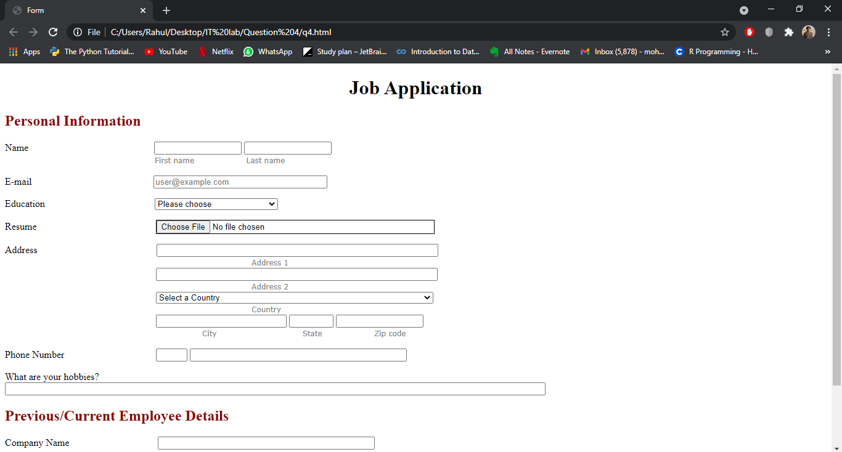

**Question 5**

**File name – q5.html**

<!DOCTYPE html>

<html>

    <head>

        <meta charset="utf-8">

        <title>Kerala Tourism</title>

        <style>

            body,html{

                height: 100%;

            }

            body{

                font-family: Verdana, Geneva, Tahoma, sans-serif;

                background-image: url("https://images.unsplash.com/photo-1491497895121-1334fc14d8c9?ixid=MnwxMjA3fDB8MHxwaG90by1wYWdlfHx8fGVufDB8fHx8&ixlib=rb-1.2.1&auto=format&fit=crop&w=750&q=80");

                height: 100%;

                background-position: center;

                background-repeat: no-repeat;

                background-size: cover;

            }

            .sub{

                color: black;

                font-size: large;

            }

        </style>

    </head>

    <body>

        <h1 style="text-align: center; color: indigo;">Kerala Tourism</h1>

        <marquee behavior="scroll" direction="right">Welcome to God's Own Country</marquee>

        <ul>

            <li><strong><a class="sub" href="festivals.html" target="_blank">Festivals</a></strong></li><br>

            <li><strong><a class="sub" href="images.html" target="_blank">Images</a></strong></li><br>

            <li><strong><a class="sub" href="videos.html" target="_blank">Videos</a></strong></li><br>

            <li><strong><a class="sub" href="hotels.html" target="_blank">Hotels</a></strong></li><br>

            <li><strong><a class="sub" href="plan.html" target="_blank">Plan a Trip</a></strong></li><br>

            <li><strong><a class="sub" href="reviews.html" target="_blank">Reviews</a></strong></li><br>

        </ul>

    </body>

</html>

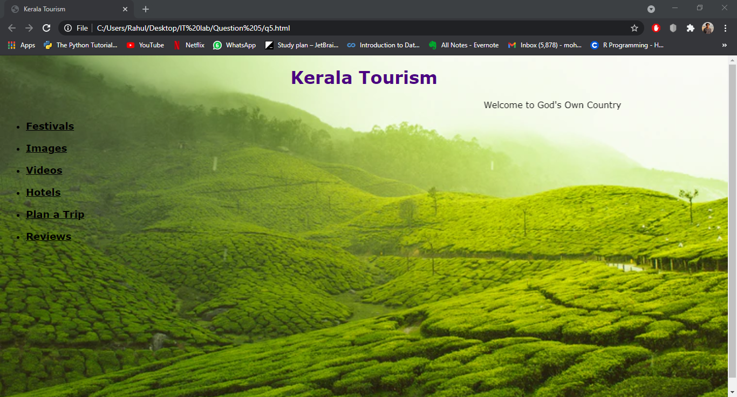

**File name – festivals.html**

<!DOCTYPE html>

<html>

    <head>

        <meta charset="utf-8">

        <title>Festivals</title>

        <style>

            body{

                background-color: #65f0f5e1;

                font-family: Georgia, 'Times New Roman', Times, serif;

            }

            p{

                font-family: Impact, Haettenschweiler, 'Arial Narrow Bold', sans-serif;

            }

            .sub{

                color: rgb(223, 18, 18);

                font-size: large;

            }

            .sub1{

                color: black;

                font-size: x-large;

            }

            h2{

                color: darkblue;

            }

        </style>

    </head>

    <body>

        <a class="sub1" href="q5.html" target="_blank">Home |</a>

        <a class="sub1" href="festivals.html" target="_blank">Festivals |</a>

        <a class="sub1" href="images.html" target="_blank">Images |</a>

        <a class="sub1" href="videos.html" target="_blank">Videos |</a>

        <a class="sub1" href="hotels.html" target="_blank">Hotels |</a>

        <a class="sub1" href="plan.html" target="_blank">Plan a Trip |</a>

        <a class="sub1" href="reviews.html" target="_blank">Reviews |</a>

        <h1 style="text-align: center;"><u>Festivals of Kerala</u></h1>

        <div style="width:100%;border:1px solid gray;padding:8px;background: url('https://www.flightcentre.co.uk/sites/flightcentre.co.uk/files/styles/fcluk_hero_desktop/public/fireworks-night-ps.jpg?itok=1cGgIGnd');">

            <p>

                <br>

                <ul style="list-style-type:square; color: blue;">

                    <li><a  class="sub" href = "#onam">Onam</a></li><br>

                    <li><a  class="sub" href = "#xmas">Christmas</a></li><br>

                    <li><a  class="sub" href = "#vishu">Vishu</a></li><br>

                    <li><a  class="sub" href = "#easter">Easter</a></li><br>

                    <li><a  class="sub" href = "#ramadan">Ramadan</a></li><br>

                    <li><a  class="sub" href = "#muharram">Muharram</a></li><br>

                    <li><a  class="sub" href = "#shiva">Maha Shivaratri</a></li><br>

                    <li><a  class="sub" href = "#diwali">Deepavali</a></li>

                    <br>

                </ul>

            </p>

        </div>

        <h2 id="onam"><em><u>Onam</u></em></h2>

        <p>

            One of the most important and famous festivals is the Onam festival of Kerala. It is the harvest festival of Kerala that falls in the Malayalam month of Chingam. It is celebrated to commemorate the Vamana avatar of Lord Vishnu and the homecoming of King Mahabali.

            Around Onam, the whole state gets drenched in the festive spirit, marked with delicious dishes, dance, music, rituals and boat races.

            It is also the state festival of Kerala.

        </p>

        <hr>

        <h2 id="xmas"><em><u>Christmas</u></em></h2>

        <p>

            In the state of Kerala, where Christians account for over a quarter of the population, Christmas holds a strong position. With festivities ranging from shopping and tree decorations to carols and feast, Christmas is definitely one of the most celebrated festivals in Kerala.

            The festival marks the birth of Jesus Christ.

        </p>

        <hr>

        <h2 id="vishu"><em><u>Vishu</u></em></h2>

        <p>

            Vishu marks the beginning of Malayalam year and is one of the most important and famous festivals of Kerala.

            Mostly celebrated at home, a pooja with the family and the evening feast are the highlights of this Hindu festival.

        </p>

        <hr>

        <h2 id="easter"><em><u>Easter</u></em></h2>

        <p>

            Easter is the oldest Christian festival, the Central tenet of Christianity is not the birth of Jesus, however his resurrection.

            Easter stemmed from this paschal mystery and also from the occasions of Good Friday.

        </p>

        <hr>

        <h2 id="ramadan"><em><u>Ramadan</u></em></h2>

        <p>

            Ramadan is starting same day of the Islamic schedule, in this month Muslims around the world fast as well as worship God.

        </p>

        <hr>

        <h2 id="muharram"><em><u>Muharram</u></em></h2>

        <p>

            Muharram is the first month of the Islamic Calendar. The full month of Muharram is spiritual according to the Muslims. Nonetheless, it is the tenth day which is of the majority of relevance. Different factions of the Muslim community observe now for different reasons.

        </p>

        <hr>

        <h2 id="shiva"><em><u>Maha Shivaratri</u></em></h2>

        <p>

            Maha Shivratri- the night of Lord Shiva is a famous Hindu event commemorated with massive zeal and also excitement in different parts of the nation.The festival is usually celebrated in the month of Feb-Mar according to the Hindu Lunar Schedule.

        </p>

        <hr>

        <h2 id="diwali"><em><u>Deepavali</u></em></h2>

        <p>

            The Festival of Lights is called Deepavali, this is the name of the festival in Southern India and this is just how the festival is referred to in other Oriental nations such as Malaysia as well as Singapore.

            In North India, it is more typically called Diwali.

        </p>

    </body>

</html>

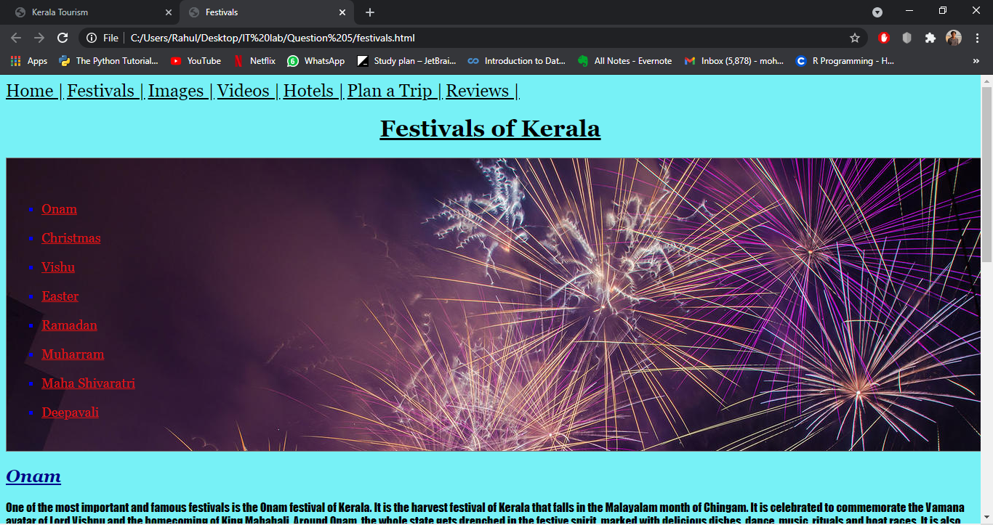

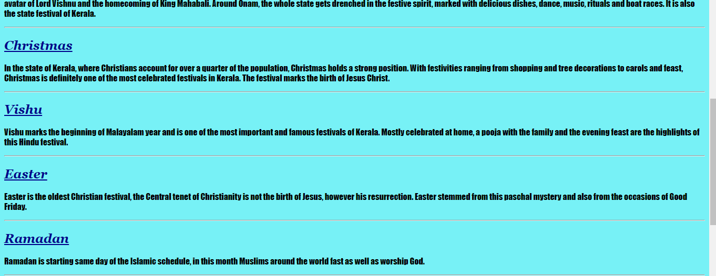

**File name – images.html**

<!DOCTYPE html>

<html>

    <head>

        <meta charset="utf-8">

        <title>Photos</title>

        <style>

            div{

                background: url('https://encrypted-tbn0.gstatic.com/images?q=tbn:ANd9GcQpBKJ64egcKgRZANIankmXIHGFuxUNibKEWQ&usqp=CAU');

            }

            body{

                background-color: salmon;

            }

            .sub{

                color: black;

                font-size: x-large;

            }

        </style>

    </head>

    <body>

        <a class="sub" href="q5.html" target="_blank">Home |</a>

        <a class="sub" href="festivals.html" target="_blank">Festivals |</a>

        <a class="sub" href="images.html" target="_blank">Images |</a>

        <a class="sub" href="videos.html" target="_blank">Videos |</a>

        <a class="sub" href="hotels.html" target="_blank">Hotels |</a>

        <a class="sub" href="plan.html" target="_blank">Plan a Trip |</a>

        <a class="sub" href="reviews.html" target="_blank">Reviews |</a>

        <div style="width: auto;border:medium solid black;padding:8px;">

            <img src="https://blog.thomascook.in/wp-content/uploads/2020/08/Kerala-banner.jpg" width="400" height="380">

            &nbsp&nbsp;

            <img src="https://curlytales.com/wp-content/uploads/2020/06/kerala-165347_960_720.jpg" width="500" height="390">

            &nbsp&nbsp;

            <img src="https://lp-cms-production.imgix.net/2019-06/GettyImages-555344865_super.jpg?auto=format&fit=crop&ixlib=react-8.6.4&h=520&w=1312" width="375" height="340">

            <img src="https://media.worldnomads.com/Explore/india/kerala-backwaters-canoe-istock.jpg" height="300">

            &nbsp&nbsp;

            <img src="https://upload.wikimedia.org/wikipedia/commons/thumb/e/ef/Thiruvananthapuram_Padmanabhaswamy_Temple.jpg/1200px-Thiruvananthapuram_Padmanabhaswamy_Temple.jpg" width="400" height="280">

            <img src="https://encrypted-tbn0.gstatic.com/images?q=tbn:ANd9GcSQy95jYQf9c6wA-xw4VrXm6D90o8cgSq1fWA&usqp=CAU" width="425">

            <img src="https://img.traveltriangle.com/blog/wp-content/uploads/2016/12/best-places-to-visit-in-kerala.jpg" width="400">

            &nbsp&nbsp&nbsp;

            <img src="https://www.keralatourism.org/images/picture/large/Thrissur_pooram_one_of_a_kind_51.jpg" width="500" height="270">

            <img src="https://encrypted-tbn0.gstatic.com/images?q=tbn:ANd9GcRG5kjQX1KbI1nqbD1hoyJotr19IJr8XEcpGQ&usqp=CAU" width="370">

        </div>

    </body>

</html>

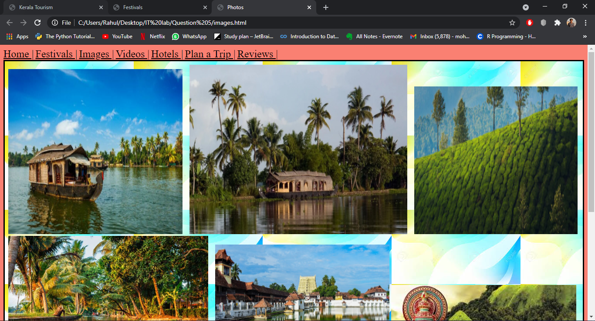

**File name – videos.html**

<!DOCTYPE html>

<html>

    <head>

        <meta charset="utf-8">

        <title>Videos</title>

        <style>

            body,html{

                height: 100%;

            }

            body{

                background-image:url(https://wallpapercave.com/wp/MgMYE5Z.jpg);

                height: 100%;

                background-position: center;

                background-repeat: no-repeat;

                background-size: cover;

            }

            .sub{

                display: block;

                margin-top: 100px;

                margin-right: auto;

                margin-left: auto;

                margin-bottom: 100px;

                width: 50%;

            }

            .sub1{

                color: black;

                font-size: x-large;

            }

        </style>

    </head>

    <body>

        <a class="sub1" href="q5.html" target="_blank">Home |</a>

        <a class="sub1" href="festivals.html" target="_blank">Festivals |</a>

        <a class="sub1" href="images.html" target="_blank">Images |</a>

        <a class="sub1" href="videos.html" target="_blank">Videos |</a>

        <a class="sub1" href="hotels.html" target="_blank">Hotels |</a>

        <a class="sub1" href="plan.html" target="_blank">Plan a Trip |</a>

        <a class="sub1" href="reviews.html" target="_blank">Reviews |</a>

        <iframe class="sub" width="660" height="400"src="https://www.youtube.com/embed/OQapF-EtEqk" title="YouTube video player" frameborder="0" allow="accelerometer; autoplay; clipboard-write; encrypted-media; gyroscope; picture-in-picture" allowfullscreen></iframe>

    </body>

</html>

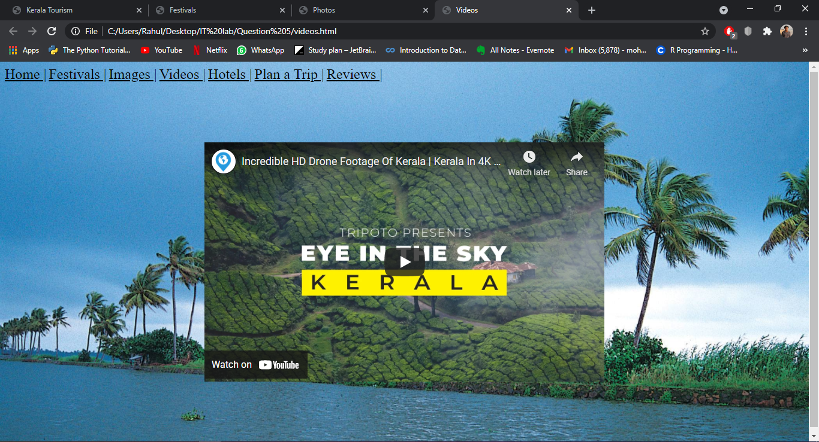

**File name – hotels.html**

<!DOCTYPE html>

<html>

    <head>

        <meta charset="utf-8">

        <title>Hotels</title>

        <style>

            body{

                background-color: greenyellow;

                font-family: 'Franklin Gothic Medium', 'Arial Narrow', Arial, sans-serif;

            }

            div{

                margin: auto;

                background-color: goldenrod;

            }

            .sub{

                font-size: x-large;

                color: firebrick;

            }

            .sub1{

                color: black;

                font-size: x-large;

            }

        </style>

    </head>

    <body>

        <a class="sub1" href="q5.html" target="_blank">Home |</a>

        <a class="sub1" href="festivals.html" target="_blank">Festivals |</a>

        <a class="sub1" href="images.html" target="_blank">Images |</a>

        <a class="sub1" href="videos.html" target="_blank">Videos |</a>

        <a class="sub1" href="hotels.html" target="_blank">Hotels |</a>

        <a class="sub1" href="plan.html" target="_blank">Plan a Trip |</a>

        <a class="sub1" href="reviews.html" target="_blank">Reviews |</a>

        <h1 style="text-align: center;"><u>Hotels in Kerala</u></h1>

        <div style="width:90%;border:medium solid black;padding:8px;">

            <ul>

                <li><a class="sub" href="https://www.keralatourism.org/hotels/issac-residency/2568" target="_blank">Issac Residency</a></li><br>

                <li><a class="sub" href="https://www.keralatourism.org/hotels/forest-canopy/2574" target="_blank">Forest Canopy</a></li><br>

                <li><a class="sub" href="https://www.keralatourism.org/hotels/transit-hotel/4922" target="_blank">Transit Hotel</a></li><br>

                <li><a class="sub" href="https://www.keralatourism.org/hotels/palace-inn/2504" target="_blank">Palace Inn</a></li><br>

                <li><a class="sub" href="https://www.keralatourism.org/hotels/la-promenade-hotel/3595" target="_blank">La Promenade Hotel</a></li><br>

                <li><a class="sub" href="https://www.keralatourism.org/hotels/jasmine-palace/4365" target="_blank">Jasmine Palace</a></li><br>

                <li><a class="sub" href="https://www.keralatourism.org/hotels/fort-house-hotel/3355" target="_blank">Fort House Hotel</a></li><br>

                <li><a class="sub" href="https://www.keralatourism.org/hotels/rose-residency/2083" target="_blank">Rose Residency</a></li><br>

                <li><a class="sub" href="https://www.keralatourism.org/hotels/hotel-indraprastha/2101" target="_blank">Hotel Indraprastha</a></li><br>

                <li><a class="sub" href="https://www.keralatourism.org/hotels/hotel-coral-heights/2111" target="_blank">Hotel Coral Heights</a></li><br>

            </ul>

        </div>

    </body>

</html>

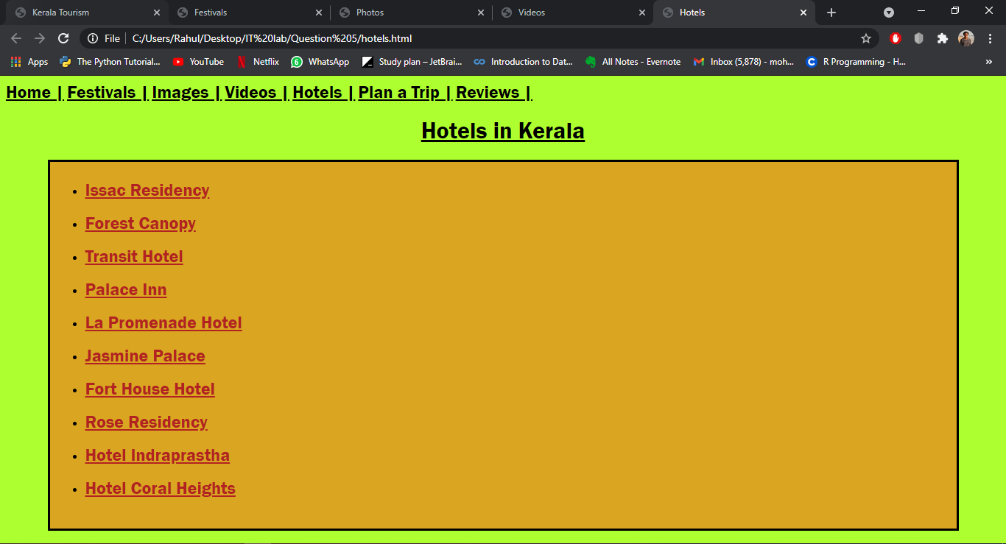

**File name – plan.html**

<!DOCTYPE html>

<html>

    <head>

        <meta charset="utf-8">

        <title>Plan trip</title>

        <style>

            #fname{

                margin-left: 210px;

            }

            #email{

                margin-left: 210px;

            }

            #phcode{

                margin-left: 150px;

            }

            #month{

                margin-left: 80px;

            }

            .csubs{

                font-size: 12px;

                font-weight: 600;

                color: brown;

                font-family: Verdana, sans-serif;

            }

            .csub1{

                margin-left: 260px;

            }

            body{

                background-color: darksalmon;

                font-family: -apple-system, BlinkMacSystemFont, 'Segoe UI', Roboto, Oxygen, Ubuntu, Cantarell, 'Open Sans', 'Helvetica Neue', sans-serif;

            }

            div{

                margin: auto;

            }

            .sub{

                color: black;

                font-size: x-large;

            }

        </style>

    </head>

    <body>

        <a class="sub" href="q5.html" target="_blank">Home |</a>

        <a class="sub" href="festivals.html" target="_blank">Festivals |</a>

        <a class="sub" href="images.html" target="_blank">Images |</a>

        <a class="sub" href="videos.html" target="_blank">Videos |</a>

        <a class="sub" href="hotels.html" target="_blank">Hotels |</a>

        <a class="sub" href="plan.html" target="_blank">Plan a Trip |</a>

        <a class="sub" href="reviews.html" target="_blank">Reviews |</a>

        <h1 style="text-align: center;">Plan your trip to Kerala now !</h1>

        <marquee behavior="scroll" direction="right">Kindly fill this form and we will contact you shortly.</marquee>

        <div style="width:90%;border:medium solid black;padding:8px;">

            <form method="post" action="http://www.deitel.com">

                <p>

                    <label>

                        Name

                    </label>

                    <input name="firstname" type="text" size="15" id="fname" required>

                    <input name="lastname" type="text" size="15" required>

                    <br>

                    <span class="csubs csub1">First name &nbsp&nbsp&nbsp&nbsp&nbsp&nbsp&nbsp&nbsp&nbsp&nbsp&nbsp&nbsp&nbsp&nbsp&nbsp&nbsp&nbspLast name</span>

                </p>

                <p>

                    <label>E-mail

                        <input name="email" type="email" id="email" size="35" placeholder="user@example.com" required>

                    </label>

                </p>

                <p>

                    <label>Phone Number

                        <input name="code" type="text" id="phcode" size="2" required>

                        <input name="phoneno" type="tel" size="25" required>

                    </label>

                </p>

                <p>

                    <label>Preferred month of travel

                        <input type="month" name="month" id="month" required>

                    </label>

                </p>

                <p>

                    <input type="Submit" name="Submit" value="Submit">

                    <input type="reset" value = "Clear">

                </p>

            </form>

        </div>

    </body>

</html>

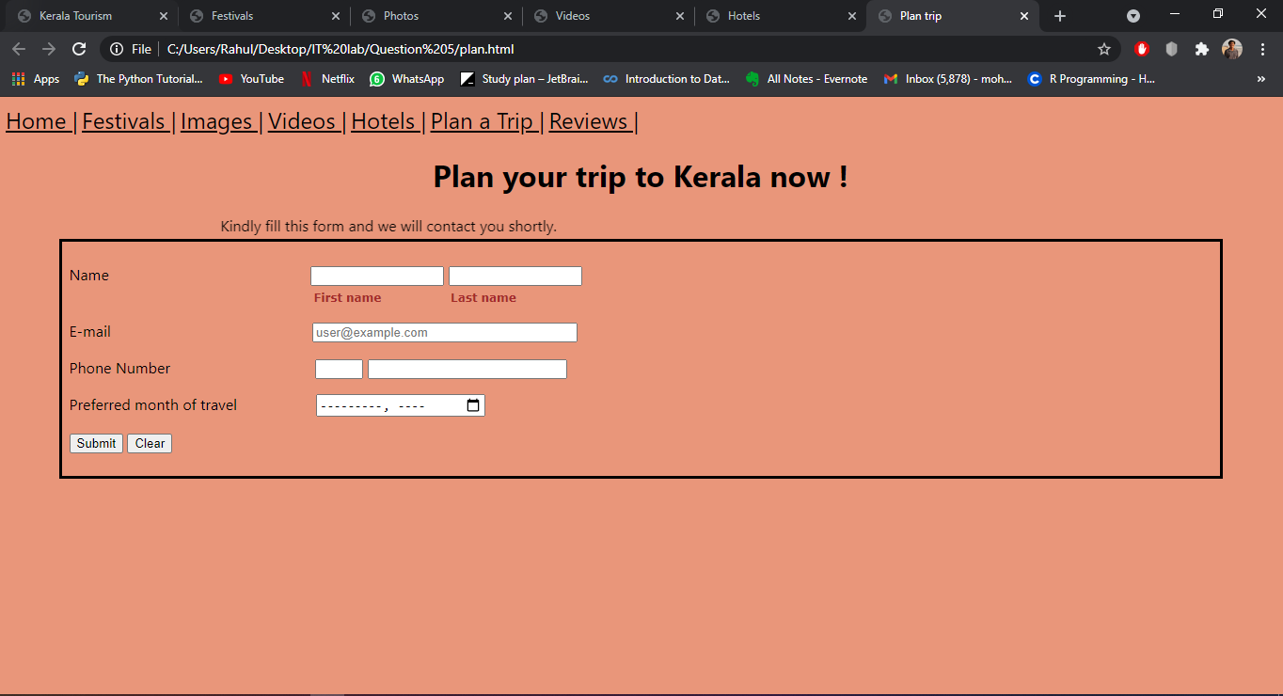

**File name – reviews.html**

<!DOCTYPE html>

<html>

    <head>

        <meta charset="utf-8">

        <title>Reviews</title>

        <style>

            body,html{

                height: 100%;

            }

            body{

                font-family: 'Courier New', Courier, monospace;

                background-image: url("https://t4.ftcdn.net/jpg/02/23/82/83/360_F_223828327_QyLrdWkm3DrVCfuHzGvTayT6vsE24d0L.jpg");

                height: 100%;

                background-position: center;

                background-repeat: no-repeat;

                background-size: cover;

            }

            .sub{

                color: black;

                font-size: x-large;

            }

        </style>

    </head>

    <body>

        <a class="sub" href="q5.html" target="_blank">Home |</a>

        <a class="sub" href="festivals.html" target="_blank">Festivals |</a>

        <a class="sub" href="images.html" target="_blank">Images |</a>

        <a class="sub" href="videos.html" target="_blank">Videos |</a>

        <a class="sub" href="hotels.html" target="_blank">Hotels |</a>

        <a class="sub" href="plan.html" target="_blank">Plan a Trip |</a>

        <a class="sub" href="reviews.html" target="_blank">Reviews |</a>

        <h1 style="text-align: center; color: darkblue;">Reviews</h1>

        <div style="width: auto;border:medium dotted black;padding:8px;">

            <span>ABC</span><br>

            <span>aa/aa/aaaa</span>

            <p>

                Lorem ipsum dolor sit amet, consectetur adipiscing elit, sed do eiusmod tempor incididunt ut labore et dolore magna aliqua. Ut enim ad minim veniam, quis nostrud exercitation ullamco laboris nisi ut aliquip ex ea commodo consequat.

                Duis aute irure dolor in reprehenderit in voluptate velit esse cillum dolore eu fugiat nulla pariatur.

            </p>

        </div>

        <br>

        <div style="width: auto;border:medium dotted black;padding:8px;">

            <span>XYZ</span><br>

            <span>xx/xx/xxxx</span>

            <p>

                Lorem ipsum dolor sit amet, consectetur adipiscing elit, sed do eiusmod tempor incididunt ut labore et dolore magna aliqua. Ut enim ad minim veniam, quis nostrud exercitation ullamco laboris nisi ut aliquip ex ea commodo consequat.

                Duis aute irure dolor in reprehenderit in voluptate velit esse cillum dolore eu fugiat nulla pariatur.

            </p>

        </div>

        <br>

        <div style="width: auto;border:medium dotted black;padding:8px;">

            <span>PQR</span><br>

            <span>qq/qq/qqqq</span>

            <p>

                Lorem ipsum dolor sit amet, consectetur adipiscing elit, sed do eiusmod tempor incididunt ut labore et dolore magna aliqua. Ut enim ad minim veniam, quis nostrud exercitation ullamco laboris nisi ut aliquip ex ea commodo consequat.

                Duis aute irure dolor in reprehenderit in voluptate velit esse cillum dolore eu fugiat nulla pariatur.

            </p>

        </div>

        <br>

        <div style="width: auto;border:medium dotted black;padding:8px;">

            <span>ABC</span><br>

            <span>aa/aa/aaaa</span>

            <p>

                Lorem ipsum dolor sit amet, consectetur adipiscing elit, sed do eiusmod tempor incididunt ut labore et dolore magna aliqua. Ut enim ad minim veniam, quis nostrud exercitation ullamco laboris nisi ut aliquip ex ea commodo consequat.

                Duis aute irure dolor in reprehenderit in voluptate velit esse cillum dolore eu fugiat nulla pariatur.

            </p>

        </div>

    </body>

</html>

